**Assignment** :

Module -1: Understanding of Hardware and Its Components

**Section 1: Multiple Choice**

1. Which of the following is NOT a component of the CPU?

1. ALU

2. RAM

3. CU

4. 1 and 3 both

Ans: RAM

2. What is the function of RAM in a computer?

ANS: Ram is the short term memory of a computer.It temporerly stores data and instruction that cpu needs while performing tasks.

3. Which of the following is a primary storage device?

1. HDD

2. SSD

3. SD card

4. 1 and 2 both

Ans: 1 and 2 both

4. What is the purpose of a GPU?

Ans: A GPU is a specialized processor designed to handle graphics and visual data. Its like the brain behind everything you see on your screen

**Section 2: True or False**

5. True or False:

The motherboard is the main circuit board of a computer where other components are attached.

Ans: True.

6. True or False:

A UPS (Uninterruptible Power Supply) is a hardware device that provides emergency power to a load when the input power source fails.

Ans: True.

7. True or False:

An expansion card is a circuit board that enhances the functionality of a component.

Ans: True.

**Section 3: Short Answer**

8. Explain the difference between HDD and SSD.

Ans:

| **Feature** | **HDD (Hard Disk Drive)** | **SSD (Solid State Drive)** |
| --- | --- | --- |
| **Technology** | Magnetic spinning disks | Flash memory (no moving parts) |
| **Speed** | Slower read/write speeds | Much faster performance |
| **Durability** | Prone to damage from shock | More resistant to physical damage |
| **Noise** | Audible spinning and clicking sounds | Completely silent |
| **Power Consumption** | Higher | Lower |
| **Cost** | Cheaper per GB | More expensive per GB |
| **Capacity** | Typically larger (up to several TBs) | Often smaller, though large SSDs exist |
| **Lifespan** | Longer for constant large writes | May wear out faster with heavy write use |

9. Describe the function of BIOS in a computer system.

Ans: BIOS stands for the **basic input/output system**. It’s a small program stored on a chip on the motherboard that plays a crucial role in starting your computer.

10. List and briefly explain three input devices commonly used with computers.

Ans. **INPUT DEVICE:**

**.**Keyboard: Allows user to input text ,numbers and commands

**.**Mouse: Controls the on-screen pointer and enables selection ,dragging and clicking

**.**Microphone: Captures audio input for recording or communication.

**Section 4: Practical Application**

**11. Identify and label the following components on a diagram of a motherboard:**

● CPU

● RAM slots

● SATA connectors

● PCI-E slot

ANS:

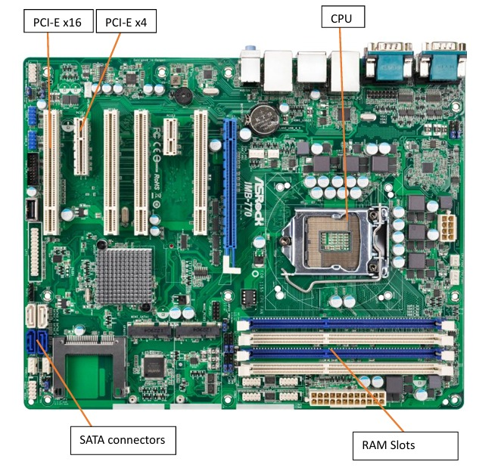

12. Demonstrate how to install a RAM module into a computer.

#### Ans: 1. Preparation

* **Turn off the computer** and unplug it from the power source.
* **Ground yourself** to prevent static discharge—touch a metal part of the case or wear an anti-static wrist strap.
* Open the computer case to access the motherboard.

#### 2. ****Identify the RAM Slots****

* Locate the **DIMM slots** on the motherboard.
* If you're adding RAM, check which slots are available and consult your motherboard manual for optimal configuration (e.g., dual-channel setup).

#### 3. ****Install the RAM Module****

* **Unlock the clips** on both ends of the RAM slot.
* Align the **notch on the RAM stick** with the slot—it only fits one way.
* Firmly press the RAM into the slot until the clips snap back into place.

#### 4. ****Verify Installation****

* Close the case and reconnect power.
* Turn on the computer and enter the BIOS (usually by pressing DEL or F2 during startup).
* Check if the system recognizes the new RAM.

#### 6. ****Troubleshooting****

* If your PC doesn’t boot, reseat the RAM or try different slots.
* Make sure the RAM is compatible with your motherboard.

**Section 5: Essay**

13. Discuss the importance of proper cooling mechanisms in a computer system. Include examples of cooling methods and their effectiveness.

**Ans:** Importance of Proper Cooling in a Computer System

.Why Cooling Matters

* **Prevents Overheating**: Excess heat can damage components like the CPU, GPU, and motherboard.
* **Maintains Performance**: High temperatures cause thermal throttling, where processors slow down to avoid damage.
* **Extends Lifespan**: Cooler components wear out more slowly, reducing the risk of failure.
* **Ensures Stability**: Overheated systems may crash or behave unpredictably.

14. Explain the concept of bus width and its significance in computer architecture.

Ans: in computer architecture,a bus is a communication pathway that transfer data between components-like the cpu,memory,and peripherals.the bus width refers to the number of bits that can be transferred simulantuesly.

• A **32-bit bus** can carry 32 bits of data at once.

• A **64-bit bus** can carry 64 bits at once—twice as much.

### 1. **Data Transfer Speed**

* Wider buses move more data per clock cycle.
* A 64-bit bus can transfer twice the data of a 32-bit bus at the same frequency.

### 2. **System Performance**

* Affects how quickly the CPU can access memory and peripherals.
* Wider buses reduce bottlenecks in high-performance tasks like gaming, video editing, and scientific computing.